Numeracy Activity: Mathematical Bingo
I have prepared a math bingo game for our Numeracy activity on Friday. Please play this game with your class for the last half hour of Period 2 on Friday (from 11:20 am- 11:50 am). If you have any questions, please ask!

Have fun!
Karen

Instructions:
Before Class:
- Please photocopy enough bingo cards for your students (Day 2, period 2)
- Make sure you have a dry erase marker for your whiteboard.

During Class:
- Distribute a bingo card and scrap paper to each student.
- Have your students fill in their bingo card with numbers by randomly choosing numbers for each column.
- When everyone is ready, draw an operation from the envelope.
- Write the operation on the board, and agree on the answer as a class.

I set up each operation so that the answer is in bold on the left. The operation that you write on the board is on the right.

33 | 11 x 3

Answer operation

- Student mark their square with that number, if they have it.
- Keep a list of numbers on the board as they are called. (Do not return numbers to envelope. Each number should only be drawn once.)
- Play to a line. Continue to two line or full house as you see fit.
- Give your winners a winner ticket.
- Winners can choose a prize in the foyer at lunch! They must have their winners ticket to collect their prize.

1 | 1² | 26 | 13 x 2 | 51 | 25 + 26
2 | 30/15 | 27 | 3³ | 52 | 26 x 2
3 | 15/5 | 28 | 7 x 4 | 53 | 25 + 28
4 | 2² | 29 | 19 +10 | 54 | 9 x 6
5 | 100/20 | 30 | 90/3 | 55 | 110/2
6 | 36 | 31 | 15 + 16 | 56 | 7 x 8
7 | 49 | 32 | 16 x 2 | 57 | 48 + 9
8 | 64 | 33 | 11 x 3 | 58 | 29 + 29
9 | 81 | 34 | 28 + 6 | 59 | 100- 41
10 | 1000/100 | 35 | 70/2 | 60 | 15 x 4
11 | 110/10 | 36 | 6² | 61 | 55 + 6
12 | 3 x 4 | 37 | 50-13 | 62 | 100 - 38
13 | 22 - 9 | 38 | 19 x 2 | 63 | 80-17
14 | 30-16 | 39 | 41-2 | 64 | 8²
15 | 45/3 | 40 | 120/3 | 65 | 13 x 5
16 | 4² | 41 | 100 - 59 | 66 | 33 x 2
17 | 8+9 | 42 | 19+23 | 67 | 70 - 3
18 | 36/2 | 43 | 49-6 | 68 | 17 x 4
19 | 40-21 | 44 | 11 x 4 | 69 | 100-31
20 | 100/5 | 45 | 9 x 5 | 70 | 350/5
21 | 7 x 3 | 46 | 23 x 2 | 71 | 50 + 21
22 | 66/3 | 47 | 29 + 18 | 72 | 12 x 6
23 | 50-27 | 48 | 12 x 4 | 73 | 100 - 27
24 | 48/2 | 49 | 7² | 74 | 75 – 1
25 | 5² | 50 | 500/10 | 75 | 25 x 3
Mathematical Bingo
Complete your bingo card by choosing numbers for each category.

Under B: 1-15
Under I: 16-30
Under N: 31-45
Under G: 46-60
Under O: 61-75

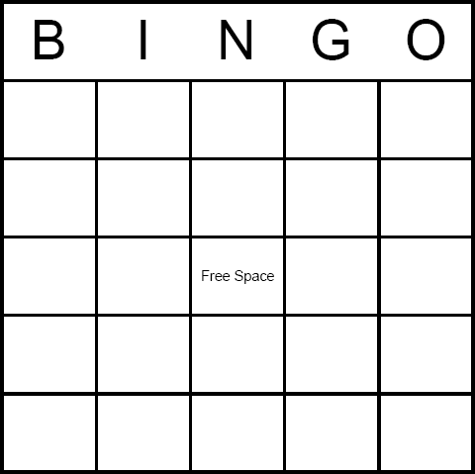
Nipakinaake
( I won )

Mathematical Bingo Winner!
Kapakinaakec
( The one who won )
Name: ___________
Class: ___________
Mathematical Bingo Winner!
Kapakinaakec
( The one who won )
Name: ___________
Class: ___________
Mathematical Bingo Winner!
Kapakinaakec
( The one who won )
Name: ___________
Class: ___________

