Management Board
 Listening Station Big Book Station

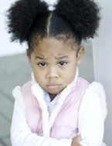 Overhead Station Word Study

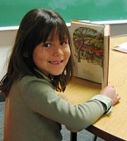 Writing Station Buddy Reading

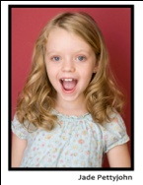 Buddy Reading Listening Station

 Big Book Station Drama Station

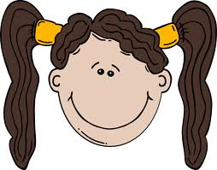 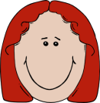 Word Study Overhead Station

 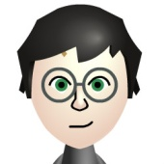 Drama Station Writing Station

In this management board the students are represented by their pictures. You can also just write the pairs of students onto an index card. Left side of the chart is names of students. Green column is the first station that the students will go to. The Red column is the second station that the students will go to. With Primary students you also need to have pictures that show what the workstation is so the students will know where to go. *Note stations in Green and Red Column are the same. When rotating the workstation for the next day move the bottom card of the workstations up to the top and rotate everything down one slot.

When you are ready to begin small group work with the workstations you need to cover the slots of the students you would like to work with. Then they know that they will go to small group instead of moving to a workstation.

Listening Station Big Book Station
Meet with Teacher

Overhead Station Word Study
Meet with Teacher

Writing Station Buddy Reading
Meet with Teacher

Buddy Reading Listening Station
Meet with Teacher

Big Book Station Drama Station

Word Study Overhead Station
Meet with Teacher

Drama Station Writing Station
Meet with Teacher

For the older grades your management board may look like this:
